**TASK 1: Create a web service of online add to cart system**

**SOLUTION:**

using System;

using System.Collections.Generic;

using System.Linq;

using System.Web;

using System.Web.Services;

namespace WebServices2

{

/// <summary>

/// Summary description for CartService

/// </summary>

[WebService(Namespace = "http://tempuri.org/")]

[WebServiceBinding(ConformsTo = WsiProfiles.BasicProfile1_1)]

[System.ComponentModel.ToolboxItem(false)]

// To allow this Web Service to be called from script, using ASP.NET AJAX, uncomment the following line.

// [System.Web.Script.Services.ScriptService]

public class CartService : System.Web.Services.WebService

{

private static List<CartItem> cartItems = new List<CartItem>();

[WebMethod]

public void AddToCart(string itemId, int quantity)

{

// Check if the item already exists in the cart

CartItem existingItem = cartItems.FirstOrDefault(item => item.ItemId == itemId);

if (existingItem != null)

{

existingItem.Quantity += quantity;

}

else

{

// Fetch item details from a database or any other source

string itemName = GetItemName(itemId);

decimal price = GetItemPrice(itemId);

// Create a new cart item

CartItem newItem = new CartItem

{

ItemId = itemId,

ItemName = itemName,

Price = price,

Quantity = quantity

};

cartItems.Add(newItem);

}

}

[WebMethod]

public void RemoveFromCart(string itemId)

{

// Find the item in the cart

CartItem itemToRemove = cartItems.FirstOrDefault(item => item.ItemId == itemId);

if (itemToRemove != null)

{

cartItems.Remove(itemToRemove);

}

}

[WebMethod]

public List<CartItem> GetCartItems()

{

return cartItems;

}

// Dummy methods to retrieve item details (replace with your own implementation)

private string GetItemName(string itemId)

{

// Fetch the item name from a database or any other source

return "Item " + itemId;

}

private decimal GetItemPrice(string itemId)

{

// Fetch the item price from a database or any other source

return 59.99m;

}

}

public class CartItem

{

public string ItemId { get; set; }

public string ItemName { get; set; }

public decimal Price { get; set; }

public int Quantity { get; set; }

}

}

**OUTPUT:**

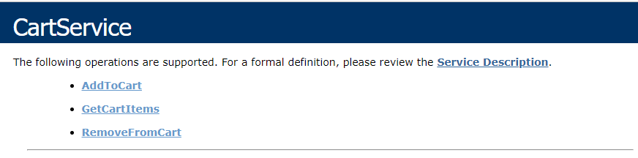

**TASK 2: Create a simple calculator web service to perform task**

**SOLUTION:**

**SERVICE CLASS:**

using System;

using System.Collections.Generic;

using System.Linq;

using System.Web;

using System.Web.Services;

namespace WebServices2

{

/// <summary>

/// Summary description for CartService

/// </summary>

[WebService(Namespace = "http://tempuri.org/")]

[WebServiceBinding(ConformsTo = WsiProfiles.BasicProfile1_1)]

[System.ComponentModel.ToolboxItem(false)]

// To allow this Web Service to be called from script, using ASP.NET AJAX, uncomment the following line.

// [System.Web.Script.Services.ScriptService]

public class CartService : System.Web.Services.WebService

{

private static List<CartItem> cartItems = new List<CartItem>();

[WebMethod]

public void AddToCart(string itemId, int quantity)

{

// Check if the item already exists in the cart

CartItem existingItem = cartItems.FirstOrDefault(item => item.ItemId == itemId);

if (existingItem != null)

{

existingItem.Quantity += quantity;

}

else

{

// Fetch item details from a database or any other source

string itemName = GetItemName(itemId);

decimal price = GetItemPrice(itemId);

// Create a new cart item

CartItem newItem = new CartItem

{

ItemId = itemId,

ItemName = itemName,

Price = price,

Quantity = quantity

};

cartItems.Add(newItem);

}

}

[WebMethod]

public void RemoveFromCart(string itemId)

{

// Find the item in the cart

CartItem itemToRemove = cartItems.FirstOrDefault(item => item.ItemId == itemId);

if (itemToRemove != null)

{

cartItems.Remove(itemToRemove);

}

}

[WebMethod]

public List<CartItem> GetCartItems()

{

return cartItems;

}

// Dummy methods to retrieve item details (replace with your own implementation)

private string GetItemName(string itemId)

{

// Fetch the item name from a database or any other source

return "Item " + itemId;

}

private decimal GetItemPrice(string itemId)

{

// Fetch the item price from a database or any other source

return 11.99m;

}

}

public class CartItem

{

public string ItemId { get; set; }

public string ItemName { get; set; }

public decimal Price { get; set; }

public int Quantity { get; set; }

}

}



